

**YEAR: 7**

**2017**

**SUBJECT: Science**

**TEST: Mixtures**

**TIME: 45 minutes**

**QUESTIONS: 10 Multiple Choice (10 marks)**

**6 Short Answer (25 marks)**

**TOTAL MARKS: 35 marks**

**DO NOT WRITE ON OR MARK THIS PAPER**

**SECTION ONE—MULTIPLE CHOICE** (10 marks)

This section has **10** questions. Answer **all** questions on the separate Multiple-choice Answer Sheet provided.

1. Particles do not move at all in
2. Solids
3. Liquids
4. Gases
5. None of the above
6. Which of the following is a pure substance?
7. cordial
8. soap
9. gold
10. salt water
11. Sugar dissolves easily in water, therefore sugar is said to be
12. insoluble
13. a solution
14. insolvent
15. soluble
16. Which beaker contains the most dilute solution?

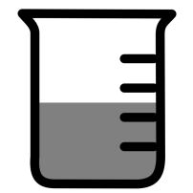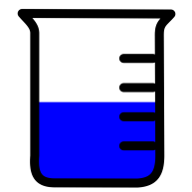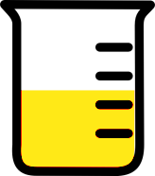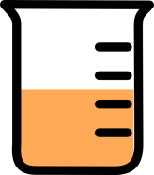

a) b) c) d)

1. An example of an emulsifier is

a) oil

b) detergent

c) water

d) salt

1. A suspension is different from a colloid because
2. Light reflects off the particles of a suspension
3. Suspensions are clear
4. The particles of a suspension will settle if left over time
5. Suspensions cannot be filtered
6. Which of the following is insoluble in water?

a) sugar

b) copper sulfate

c) detergent

d) oil

1. When a large amount (but not the maximum amount) of a solute is dissolved in a solvent, the solution is called
2. saturated
3. concentrated
4. dilute
5. a suspension
6. An example of a colloid which is also an emulsion is

a) milk

b) whipped cream

c) mayonnaise

d) gelatin

10. Which diagram represents a saturated solution?

= dissolved solid particle

= undissolved solid particle

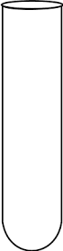

a) b) c) d)

**END OF MULTIPLE CHOICE SECTION**



**SEMESTER TWO 2017**

**Mixtures Test**

**ANSWER BOOKLET**

**NAME:**

**FORM:** **DATE:**

Multiple Choice Short Answer Total

**/25**

**/10**

**/35**

**SECTION ONE:** Multiple choice answers

Cross (X) through the correct answer.

|  |  |  |  |  |
| --- | --- | --- | --- | --- |
| **1** | a | b | **XXX** | D |
| **2** | a | b | c | **XXX** |
| **3** | a | b | **XXX** | D |
| **4** | a | **XXX** | c | D |
| **5** | a | b | **XXX** | D |
| **6** | a | b | c | **XXX** |
| **7** | a | **XXX** | c | D |
| **8** | **XXX** | b | c | D |
| **9** | a | b | **XXX** | D |
| **10** | a | **XXX** | c | D |

**SECTION TWO: Short Answer (25 marks)**

Answer the questions in the spaces provided.

1. Match the terms to their definition by drawing a line between them. (4 marks)

|  |  |
| --- | --- |
| Mixture | A cloudy mixture containing insoluble particles that don’t settle |
| Solution | a see-through mixture of one substance dissolved in another |
| Colloid | A mixture of two or more liquids that don’t dissolve in each other |
| Emulsion | A substance made from two or more pure substances that have been stirred together |

1. Wax is a solid that will not dissolve in water, but wax does dissolve in kerosene. Sugar will dissolve in water but not in kerosene. Kerosene will not dissolve in water. (3 marks)

1. a) **Identify** the solvent you would use to make a solution containing wax.

**Kerosene**

1. b) **Identify** two substances that are insoluble in water.

**Wax and kerosene**

1. c) **Identify** a substance that is soluble in water.

**Sugar**

1. 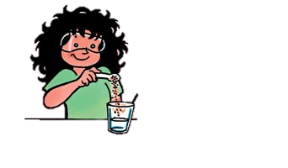Look at the information below then answer the questions that follow: (6 marks)

**Substance A**

**Substance A is dissolved in substance B.**

**Substance B**

1. What is substance A known as?

**Solute**

1. What is substance B known as?

**Solvent**

1. What is the mixture of substances A and B known as?

**Solution**

1. If only a small amount of substance A dissolved, how is the mixture described?

**Dilute**

1. If a large amount of substance A is dissolved, how is the mixture described?

**Concentrated**

1. If the maximum possible amount of substance A is dissolved, what is the mixture described as?

**Saturated**

1. What is an emulsifier and what is its job? (2 marks)

An emulsifier is **a substance that can be added to a mixture of liquids to make an emulsion**

The job of an emulsifier is to **keep the liquids in an emulsion completely mixed and stop them from separating apart**

1. Two students mix olive oil and water in the same container and shake it. (2 marks)
2. What are they likely to observe when they allow the mixture to settle?

**The oil and the water will separate**

1. What type of substance could be added to the mixture to prevent the two liquids from separating? Give an example of this substance.

Type of substance: **emulsifier**

Example of substance: **detergent**

1. Complete the table below to summarise what you know about separation techniques. (8 marks)

|  |  |  |
| --- | --- | --- |
| **Method of separation** | **Description of how it works** | **An example of how it is used in the home or in industry** |
| Magnetic separation | **Uses magnets (1/2) to attract and separate particular objects. (1/2)** | **Iron nails can be separated from non-magnetic materials like glass, aluminium and paper (1)** |
| Centrifuging | **Separates light and heavy particles (1/2) by spinning a mixture in a centrifuge.(1/2)** | **Used in diary processing factories to separate cream from milk or blood banks, salad spinners etc ( any one use) (1)** |
| Decanting | **Used to separate sediment from the liquid it is in by carefully pouring the liquid away. (1/2) Objects/ liquids that sink are denser than the liquid on top (1/2)** | **Decanting used to separate sediments from wine. (1)** |
| Evaporation | **It is used to separate dissolved solids from water (1)**  **Change in state from liquid to gas (give (1/2) mark)** | **Separating salt from salt water or to separate turpentine from water (1)** |

**END OF TEST**

**Please check your work!**